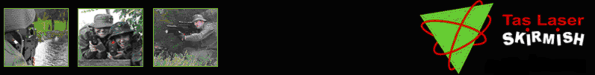

Bored? Want to have some fun with friends? Then your gonna love this…

What is it? Laser Skirmish is an outdoor team sport where you participate in 3 missions.
Mission 1 - Capture the Flag! (Base Assault)
Mission 2 - Elimination Mission
Mission 3 - Capture the Flag! (Base Assault)

Where is it? The Lea Scout Camp in Hobart. (Turn over for map reference)

When? Saturday 11th November @ 4pm

Cost? $40 per person

Please RSVP by 1st November at www.jawapro.com/forum or ring Dan @ 0418463993
Check the website for more information about the trip.

So get your sorry ass along coz we need more ppl to make it more fun. U can hitch a lift with me(Andrew) if you r hot!!! Or else you can go in dans crap car with doors that don’t open.

Bored? Want to have some fun with friends? Then your gonna love this…

What is it? Laser Skirmish is an outdoor team sport where you participate in 3 missions.
Mission 1 - Capture the Flag! (Base Assault)
Mission 2 - Elimination Mission
Mission 3 - Capture the Flag! (Base Assault)

Where is it? The Lea Scout Camp in Hobart. (Turn over for map reference)

When? Saturday 11th November @ 4pm

Cost? $40 per person

Please RSVP by 1st November at www.jawapro.com/forum or ring Dan @ 0418463993
Check the website for more information about the trip.

So get your sorry ass along coz we need more ppl to make it more fun. U can hitch a lift with me(Andrew) if you r hot!!! Or else you can go in dans crap car with doors that don’t open.

